**PHIẾU HƯỚNG DẪN HỌC SINH TỰ HỌC**

**MÔN: TIẾNG ANH 6 – TUẦN 17**

**Tiết 49,50,51**

**FURTHER PRACICE 1-2-3**

**Phiếu hướng dẫn học sinh tự học**

|  |  |
| --- | --- |
| **NỘI DUNG** | **GHI CHÚ** |
| **Tên bài học/ chủ đề - Khối lớp** | **Tiết 49,50,51**  **FURTHER PRACICE 1-2-3** |
|  | - Đọc và làm các phần trong Further practice 1,2,3.  - Xem lại phần Grammar đã học để củng cố kiến thức. |
| **Hoạt động 2**: ***Kiểm tra, đánh giá quá trình tự học.*** | **Exercise:**  1. The story is _______ two brothers.  A.with B.about C.on D.in  2. What can we do _____ the weekend?  A.on B.in C.at D.from  3. I’m _______ badminton with my sister.  A.play B.plays C.playing D.to play  4. She ____________to the gym after work.  A.usually go B.go usually C. goes usually D.usually goes  5. I’d like ________ ice cream.  A.a B.an C. some D.any  6. _______ people make their firends laugh.  A.funny B.lazy C.selfish D.kind  7. Let’s ______ to the water park .  A.goes B.going C. go D. to go  8. I like computer. That’s why I like _________.  A.I.T B.P.E C.math D.literature  9.Ho Chi Minh city is in the ______ of Vietnam.  A.north B.south C.west D.east  10. They like ________ fishing.  A.go B.going C.to go D.goes |

**Bài ghi học sinh**

**FURTHER PRACICE 1-2-3**

**FURTHER PRACTICE 1**

**I. Choose the most suitable word to fill the blanks. (circle A, B, C, or D)**

1.My parents like watching TV in the _____________ on weekends.

A. balcony B. pool C. living room D. garage

2.Tuan often eats *Banh mi* for _________ and *Pho* for lunch.

A. laundry B. living room C. breakfast D. none is correct

3.Studying _________ helps me learn about countries around the world and famous people in the past.

A. music B.history C.biology D.P.E

4. I like to learn about plants and how they grow. I like ______ .

A. I.T B.biology C.physics D.math

5.J.K.Rowling is a famous _________. She wrote the Harry Potter series.

A.novel B. teacher C.teacher D.author

6. She’s going to __________ . It’s going to have cheese and tomato on it.

A. make a cake B.make a pizza C.go to the beach D.go swimming

7.Let’s _________ . I want to go shopping and there’s a great restaurant there, too.

A. watch a movie B.have a barbecue C.play badminton D. go to the mall

8 *Emma*: How often do you go to the gym?

*Toby*: ________________________.

A. Not really B. Twice a week C. No matter, please D. Not at all

**II. Look at the sign or picture. Choose the best answer A,B,C or D**.

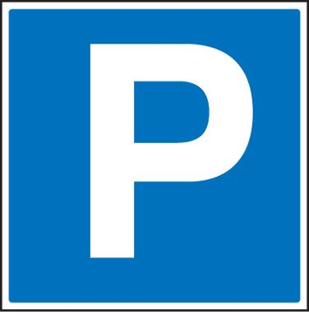1/ What is the meaning of this sign?

A/You can park here. C.You can go ahead.

B/ You can’t not go ahead. D.You can’t park here.

2.What is the meaning of this sign?

1. No dancing.
2. No cooking.
3. No eating and drinking.
4. No swimming.

**III. Match the questions in column A to the answers in column B**

|  |  |
| --- | --- |
| **A** | **B** |
| 1.Do you live in a house? | A.She cleans the kitchen. |
| 2.What housework does your sister do? | B.My mom does the dishes. |
| 3.Where’s Vancouver? | C.It’s in the west of Canada. |
| 4.Who does the dishes? | D.No, I don’t. I live in an apartment. |
| 1…………… 2………………. 3…………………. 4………………. | |

**IV. Reading comprehension**

**1/** **Read the passage and choose A, B, C or D to complete each gap:**

**My Favorite novel**

Thành Nguyễn, November 18

My favorite (1)______ is *Yellow Flowers on the Green Grass* ( tôi thấy hoa vàng trên cỏ xanh). It’s an interesting novel. The (2)______ of the book is Nguyễn Nhật Anh. The book is (3) ______ Thiều and people around him. I like the book because it shows us many beautiful things in Thiêu’(4) ______. It is a peaceful village with green grass, trees, wind, and yellow flowers. Some parts of the story (5) _____ sad. I cried a lot when I thought Thiều’s brother can not walk again. I really like this book. I think you should (6)______ it.

1. A.book B.subject C.food D. color

2. A. character B.author C.singer D. actor

3. A.about B.on C.in D.of

4. A. school B.village C.city D.town

5. A. is B.are C.have D.has

6. A. read B. reads C.reading D.to read

**2. Read the passage carefully then decide the statement is True or False**

**School club**

We have lots of fun club at our school. If you like outdoor activities, the Soccer Club meets at 4p.m every Tuesday, with the Tennis Club at the same time on Thursday. For indoor activities, the Board Games Club starts next week. It Is popular so please sign up on the noticeboard. The Book Club welcomes anyone who likes reading. You don’t need to sign up but please bring your own copy of The Secret Garden with you to the Library at 4 p.m on Wednesday. Our Arts and Crafts Club is for people who like making thing. The cost is $20 per term for materials.

1. The Soccer Club is on Tuesday.

2. You need to sing up on the noticeboard for the Board Games Club .

3. You don’t need to sign up for the Book Club.

4. The Arts and Crafts Club don’t need money.

1……….. 2………. . 3…………… 4…………..

**V. Rewrite:**

1. What/ do/ housework/ do? / you

_______________________________________________________________

2. your/ What’s/ book? / favorite

_______________________________________________________________

3. Mary/ tall/ and has/ blond hair./ is

_______________________________________________________________

4. Why don’t we play badminton?

Let’s___________________________________________________________

5. What’s your favorite subject?

What __________________________________________________________

**FURTHER PRACTICE 2**

**I. Choose the most suitable word to fill the blanks. (circle A, B, C, or D)**

1._______ people always think about themselves.

A.friendly B.lazy C.selfish D.helpful

2.Let’s play __________! We’ve strong and I’m sure we’ll beat the other team.

A.tug of war B.puppet show C. fashion show D.talent show

3. This city is famous ______ beautiful houses and museums.

A. of B. for C. in D. at

4. Why don’t you sign up ______ a book club?

A.at B.in C.on D.for

5. Where _______ live in this town?

A. does she B. does you C. do he D. she does

6.I have two _______ and they ______ students at primary school.

a. brothers/is b. brother/are

c. brothers/are d. both a and b are correct

7._________you often go shopping with your mother?

A. Do B. Does C. What D. Where

*8.Hugo*: What does your father do?

*Stephen*: ______________________.

A. Well, I do gym B. No, I do not know C. He is an English teacher D. Why not?

**II. Look at the sign or picture.Choose the best answer A,B,C or D**.

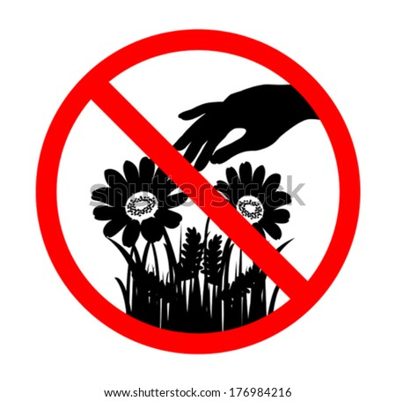1.What is the meaning of this sign?

1. Please pick up flower.
2. Don’t walk on the grass.
3. Please walk on the grass.
4. Don’t pick up flower.

2. What is the meaning of this sign?

1. Ahead only.
2. No turn left.
3. No entry.
4. No U-turn.

**III. Match the questions in column A to the answers in column B**

|  |  |
| --- | --- |
| **A** | **B** |
| 1.Do you like literature? | A.I like biology, physics, and literature. |
| 2.Which club is on Tuesday? | B.No, I don’t. |
| 3.What’s your favourite subject? | C.Sure, here you are. |
| 4. Do you have a ruler? Mine is at home. | D.The soccer club. |
| 1…………… 2………………. 3…………………. 4………………. | |

**IV. Reading comprehension**

**1/ Read the passage and choose A, B, C or D to complete each gap:**

**Housework in My Family**

Today I want _______(1) about housework in my family.

I think I do the most housework ______ (2) my family. I clean the kitchen every day. I ______(3) the dishes, too. My mom does the shopping. She’s a teacher in a ______(4). My sister is a college student. She doesn’t do anything! She doesn’t make her bed _____(5) clean her room. My dad cleans her room after work. He’s a chef in a restaurant so he makes dinner. He does the laundry and cleans the bathroom, too.

Hmm. Now, I really think _______ (6) it, my dad does the most housework.

1. A. talk B.talking C.to talk D.talks
2. A.on B.in C.of D.for
3. A.doing B.does C.did D.do
4. A.school B.hospital C.factory D.home
5. A. learn B.learning C.to learn D.learns
6. A.or B.and C.of D.with

**2. Read the passage carefully then decide the statement is True or False**

**A famous festival in Vietnam**

In Vietnam, people celebrate many different festivals each year. The biggest festival in Vietnam is Tet. This celebrates the beginning of the Lunar New Year. Vietnamese people have to prepare a lot of this festival. Before Tet, people buy fruits and flowers from the market and decorate their house. Most people buy special tree with lots of flowers. In the north of Vietnam, people buy peach tree with pink flowers. In the south of Vietnam, people buy apricot tree with yellow flowers. Everyone cleans their house before Tet. This is very important because you shouldn’t clean it during Tet. During Tet, people visit their family and friends. Few people go to school or work. Children wear new clothes and get lucky money. It’s the great time to watch lion dance and fireworks. Everyone is happy and excited about the New Year. Vietnamese people love to celebrate this festival.

1. People buy fruits and flowers during Tet.

2. Every house has the same type of tree.

3. People clean their houses during Tet.

4. You can watch lion dances during Tet.

1……….. 2…………. 3…………. 4……….

**V. Rewrite**:

1.How/ people/ do/for/prepare/ Christmas?

________________________________________________________________

2. are/ How much/ those/ shoes?

________________________________________________________________

3.sometimes/ He/ plays/ soccer

________________________________________________________________

4. She has long black hair.

Her hair_________________________________________________________

5. Do you want to drink coffee?

Would you like___________________________________________________

**FURTHER PRACTICE 3**

**I. Choose the most suitable word to fill the blanks. (circle A, B, C, or D)**

1. Where _______ live in this town?

A. does she B. does you C. do he D. she does

2.I have two _______ and they ______ students at primary school.

A. brothers/is B. brother/are

C. brothers/are D. both A and B are correct

3._________you often go shopping with your mother?

a. Do B. Does C. What D. Where

4. A ______ works in a store.

A.customer B.worker C.docctor D.sales assistant

5. Before Tết, people ________ their house.

A.cleans B.clean C.cleaning D.to clean

6. I want to try it _______?

A.in B.on C.with D.about

7. What time ______ it ______?

A.do/start B.do/starts C.does/start D.does/starts

*8.Adrian*: Excuse me, Alex. Do you live in a house?

*Sarah*: No, _________. I live in an apartment.

A. I doesn’t B. I don’t C. It is not D. I am not

**II. Look at the sign or picture.Choose the best answer A,B,C or D**.

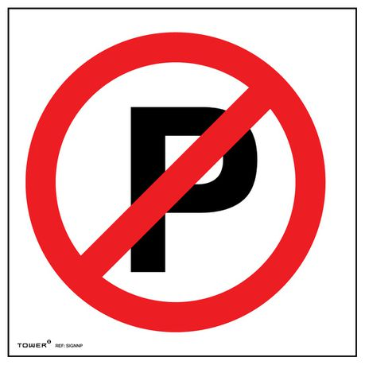1.What is the meaning of this sign?

1. Roundabout.
2. No parking.
3. No turn right.
4. Go straight ahead.

2. What is the meaning of this sign?

1. No dancing.
2. No cooking.
3. No eating and drinking.
4. No swimming.

**III. Match the questions in column A to the answers in column B**

|  |  |
| --- | --- |
| **A** | **B** |
| 1.What’s your favourite book? | A. It’s by J.K. Rowling. |
| 2.Who’s the author? | B. She is tall and has long blond hair. |
| 3.What does she look like? | C.I like Harry Potter and the Sorcerer’s Stone. |
| 4.Is he wearing glasses? | D. No, he isn’t. |
| 1…………… 2………………. 3…………………. 4………………. | |

**IV. Reading comprehension**

**1/ Read the passage and choose A, B, C or D to complete each gap:**

My favorite novel (1)______ *Five Point Someone*. It is an Indian novel. The (2)______ is Chetan Bhagat. The Story is (3)______ three students, Farhan, Raju, and Ranchoddas.

They (4)______ hard and become successful after finishing school. They help each other a lot . This shows people that they can (5)______ new things anywhere. People then made the novel into a popular Indian movie called 3 Idiots in 2009. Millions of young adults (6)______ teenagers love the novel and the movie.

1. A. is B.are C.have D.be

2. A.character B.author C.singer D.actor

3. A.of B.with C.about D.on

4. A. works B.to work C.work D.working

5. A. learn B.learning C.to learn D.learns

6. A.or B.and C.of D.with

**2. Read the passage carefully then decide the statement is True or False**

**Good sister, bad sister**

*Tâm Trần, June 21*

One of my favorite stories is from Vietnam. It’s about two sisters, Tấm and Cám. The two sisters are very different. Tấm works hard every day helping to cook and clean the house. She always thinks about other people and tries to help her family. Cám is very different to Tấm. She never does any chores and she doesn’t share anything. Cám does lots of bad things to Tấm. It’s not a nice story, but in the end, Tấm’s life is very good. I like the story because after such a hard life she is happy.

1. Tấm helps to cook and clean the house.

2. Tấm never thinks about other people.

3. Cám is the same to Tấm.

4. Cám does a lot of bad things to Tấm.

1……….. 2…………. 3………….. 4…………..

**V. Rewrite**:

1. I’m/ a/ barbecue/ on/ the weekends. / having

_________________________________________________________

2. he/ look/ he/ What/ does/ like?

_________________________________________________________

3. usually/ He/ on/ reads/ the weekend./ comic book

_________________________________________________________

4. What about going swimming?

Let’s_____________________________________________________

5. Her hair is long.

She______________________________________________________